Destiny McClain

Professor Michael Spivey

COGS 104

25 February 2020

Assignment #3: More Playing with Probability

**Part A) Triangles**

The two triangles have different measurements. This is because the two triangles that were moved are not the same triangle, they are different in base and height. In other words, the two triangles have different shapes. If they were the same shape there would most likely be no “missing square.” That missing square, however, is not actually missing but has moved into a new space. If one were to take the original triangle and overlap it with the newly formed triangle one can see that there is an area where they do not overlap. This is where the “missing square” transferred to. So, there is nothing wrong with the way the smaller triangles were arranged, but with the shape of each one being that they are not the same shape.

**Part B) Probability summation over time for the Same-Birthday Game**

clear

days=365;

people=40;

p=1;

for n=1:+1:people

n

p=p*(days-n+1)/days;

YesChance=1-p

end

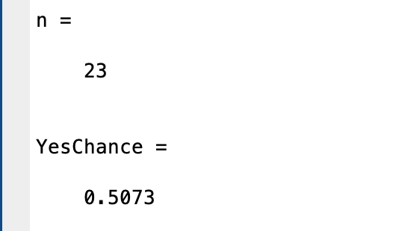

**Part C) Monte Carlo the Monty Hall Problem**

"STAYING"

clear

win=0;

contestant=1;

for t = 1:10000 %10000 times

car=randi(3);

if car==1

reveal= randi(2:3);%rand 2 or 3

end

if car==2

reveal=3;

end

if car==3

reveal=2;

end

if contestant==car

win=win+1;

end

end

win/10000

"SWITCHING"

clear

win=0;

contestant=1;

for t=1:10000

car= randi(3);

if car==1

reveal= randi(2:3); %rand 2 or 3

if reveal==2

contestant=3;

end

if reveal==3

contestant=2;

end

end

if car==2

reveal=3;

if reveal==3

contestant=2;

end

end

if car==3

reveal=2;%rand 1 or 2

if reveal==2

contestant=3;

end

end

if contestant==car

win=win+1;

end

end

win/10000

